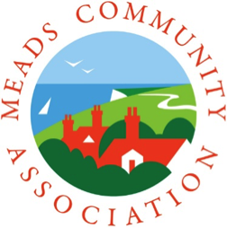
MEMBERSHIP APPLICATION

Subscription £10 per household per year
1st January – 31st December
* If you join as a new member after September
your membership will roll over to the following year *

Name: _____________________________________________________________________________________________

Address: __________________________________________________________________________________________

_____________________________________________________________________________________________________

Post Code: ___________________________________ Telephone: _______________________________________

Email Address: Please use boxes below

Meads Community Association takes your privacy seriously and we will only store and use your personal information to administer your membership. We will store this information securely and confirm that we will never pass your details to other companies or organisations.

To agree to the retention of the information above please indicate your
consent by ticking this box:

Please send £10 cash or a cheque for £10 (payable to MCA) and this completed form to MCA Membership, PO Box 3225, EASTBOURNE, BN21 9RU. If you prefer payment can be made via BACS. MCA account details are:

Sort Code 52-41-00 Account 57975590

Please use your postcode, house number and the first few letters of your surname as the reference to ensure correct identification. When payment via BACS has been made, please email the Membership Secretary at meadscommunityassociation@yahoo.co to confirm.

Cheque/cash enclosed __________ or BACS _________ date of payment _________________________

If paying by BACS this form can be emailed to meadscommunityassociation@yahoo.co.uk

www.meadscommunityassociation.org.uk

